EXPERIMENT-36
AIM
To analyze stock price variability by reading closing prices from a CSV file, calculating statistical measures, and providing insights into price movements.
ALGORITHM
- Import pandas and numpy.
- Load stock data from a CSV file.
- Extract the "Closing Price" column.
- Calculate:
- Mean price
- Standard deviation
- Minimum and maximum price
- Price range (max − min)
- Display insights.
- Optionally, plot price movement using matplotlib.
CODE
import numpy as np
import matplotlib.pyplot as plt

# Sample closing prices (no CSV required)
closing_prices = np.array([150, 152, 149, 155, 160, 158, 162, 159, 161])

# Calculations
mean_price = closing_prices.mean()
std_dev = closing_prices.std()
min_price = closing_prices.min()
max_price = closing_prices.max()
price_range = max_price - min_price

print("---- Stock Price Variability Report ----")
print(f"Average Closing Price: {mean_price:.2f}")
print(f"Standard Deviation: {std_dev:.2f}")
print(f"Minimum Price: {min_price:.2f}")
print(f"Maximum Price: {max_price:.2f}")
print(f"Price Range: {price_range:.2f}")

# Graph
plt.plot(closing_prices)
plt.title("Stock Price Movement")
plt.xlabel("Days")
plt.ylabel("Closing Price")
plt.show()
OUTPUT:
---- Stock Price Variability Report ----
Average Closing Price: 156.22
Standard Deviation: 4.61
Minimum Price: 149.00
Maximum Price: 162.00
Price Range: 13.00
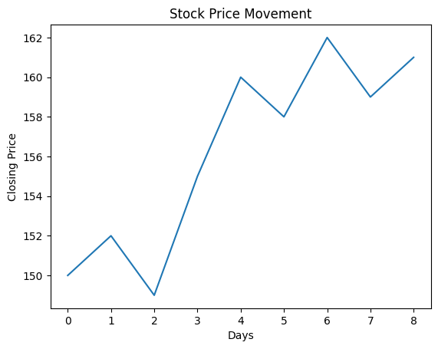
RESULT :The program successfully analyzed stock price variability using mean, standard deviation, minimum, maximum, and range, and visualized price movement over time.

